Preparing for interviews can make all the difference! | You application and resume/cover letter are just the “opening act” for your interview.  To make a good impression:  - Dress for success  - Act professionally  - Prepare and practice for interview questions
- Consider these tips when preparing for your interview: | - Research the company/organization ahead of time  - Practice interview questions before you go  - Make sure you know how to get to interview location and leave early  - Take additional copies of your resume  - Get plenty of rest the night before  - Dress your best
- Tips for getting off to a good start and making an impression in your interview include: | - Arrive 15 minutes early  - Shake interviewer’s hand firmly  - Greet the interviewer by last name  - Make good eye contact  - Show enthusiasm and energy  - Use words appropriate to your audience  - Use your best posture  - Ask about the specific job  - Be prepared to talk about your self in positive way
- Interviewers often ask you about your character traits.  Be prepared ahead of time with your top traits and examples. | Top 10 traits considered by employers:  - Attitude  - Ability to do the work  - Motivation and taking initiative  - Ability to grow in the job  - Self-confidence  - Leadership skills  - Social skills  - Team skills  - Compatability  - Communication skills
- Interviewers will often ask if you have any questions. Prepare a couple questions to ask ahead of time. | - “Please describe the tasks & responsibilities of the job?”  - “What do you consider to be the top priorities of the person in this job?”  - “What personal characteristics or skills & abilities do you believe are the most important in this job?”
- When asked about strengths and challenges, focus on presenting your answer in a positive way. | Example of stating a strength:  “I am very organized & pay close attention to details.”  Example of stating a challenge:  “Sometimes I get so caught up in my work that I forget what time it is. My supervisor reminds me take my lunch break.”
- Use the STAR method to help you provide complete responses to interview questions. | 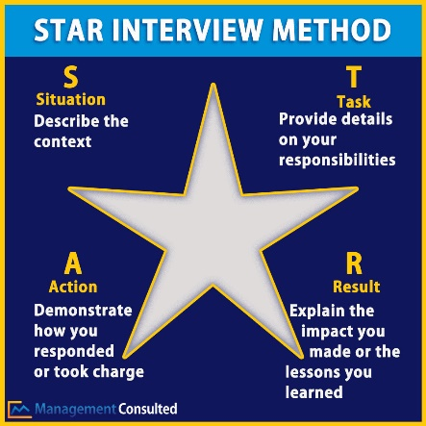
- Practice your interviewing in class: | - Review and practice questions using the Common Interview Questions hand out  - Complete a mock interview with a peer, volunteer, etc.  - Interviewers will use the Mock Interview Feedback Form to ask questions and provide feedback
- Log into Naviance | 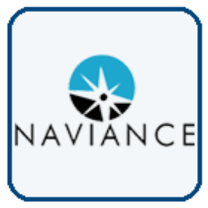  Username: district ID#  Password: district password
- Task Completion: | Click on Planner>Tasks  Click the title of the task, Complete Job Interview Reflection.

